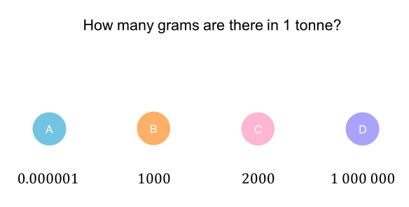 | 1) Calculate the area of the rhombus ABCD.  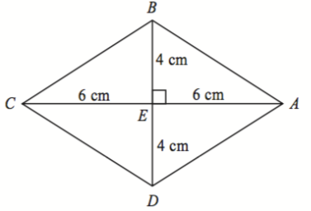  (3)  2) Here is a trapezium.  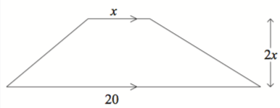  Given that the area of the trapezium is $400cm^{2}$. Show that $x^{2}+ax=b$ where $a$ and $b$ will be numbers.  (2)
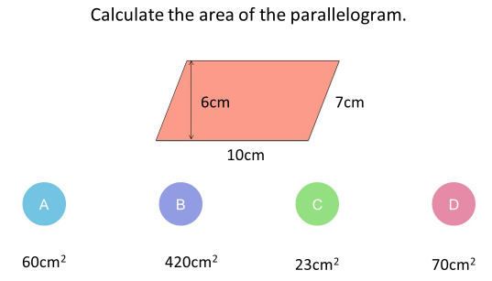
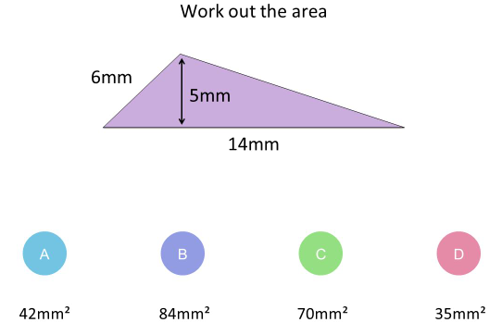
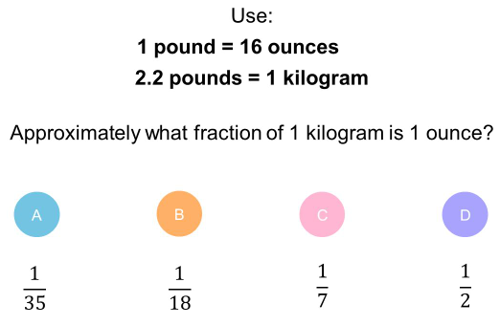
Quiz 2 for shape and space

