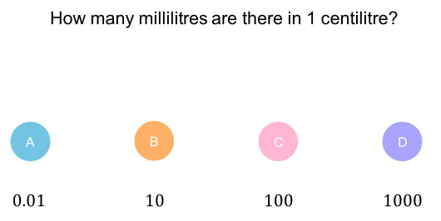 | 1) Work out the volume of the triangular prism below.  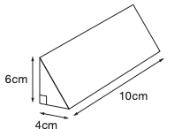  (3)  $120cm^{3}$  2) The total surface area of a cube is $294cm^{2}$. What is the volume of the cube?  (3)  $343cm^{3}$
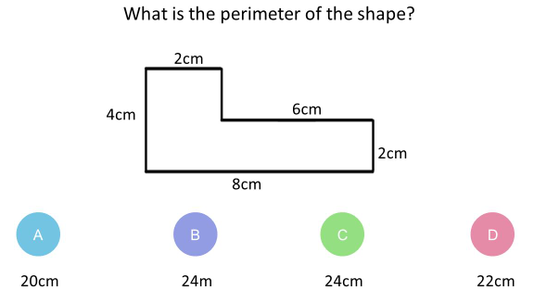
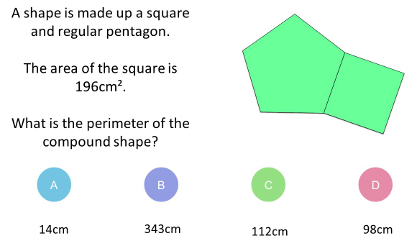
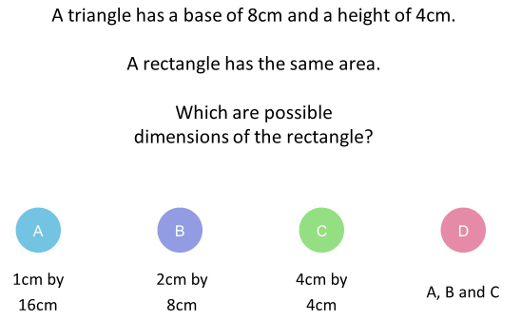
Quiz 3 for shape and space

