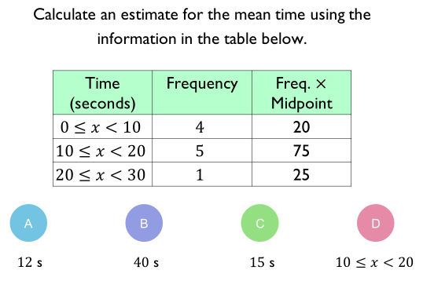 | A team has 7 boys and 3 girls. Stevie chooses two of the team at random.  (a) Complete the probability tree diagram.  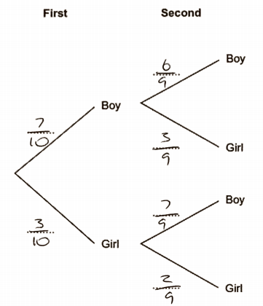  (3)  (b) Calculate the probability of choosing at least one girl.  1-(7/10 x 6/9)=1-42/90=48/90=24/45  (2)
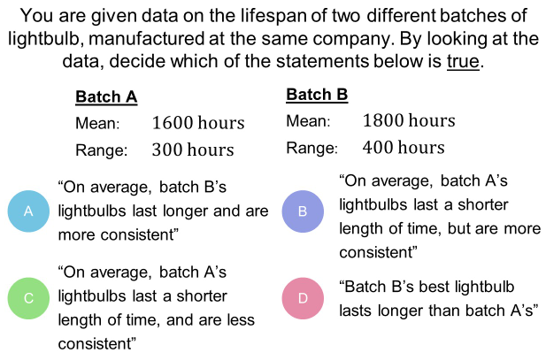
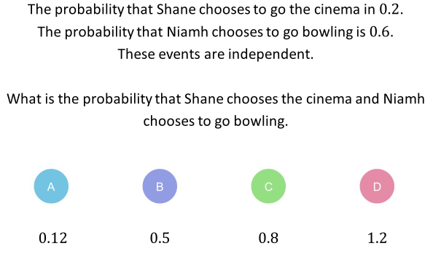
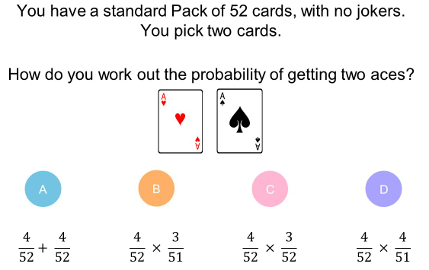
Quiz 1 for statistics and probability

