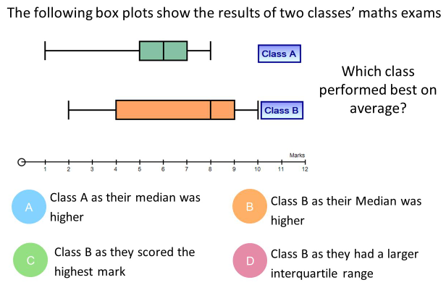 | Ted plays two games of noughts and crosses.  The probability that he wins is 0.38.  The probability that he draws is 0.47.  - Draw a tree diagram to show this situation.  (2)  - Work out the probability that Ted loses twice.  (1)  - Work out the probability that Ted wins twice.  (1)  - Work out the probability that Ted wins only one game.  (1)
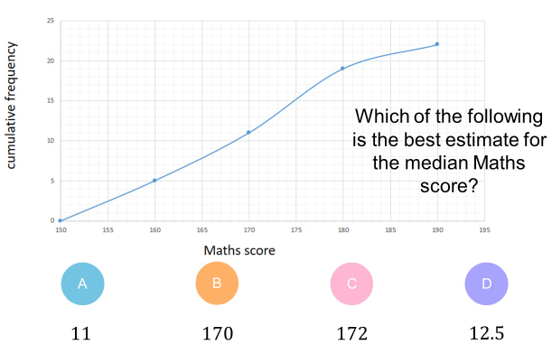
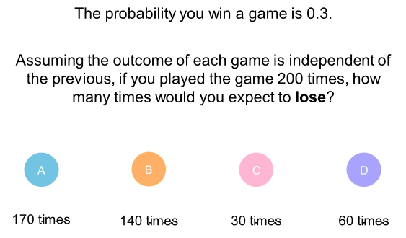
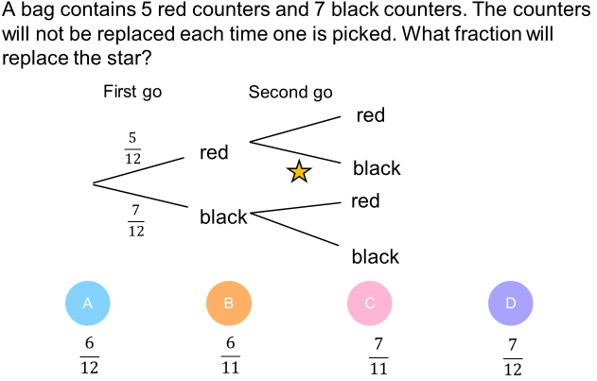
Quiz 2 for statistics and probability

