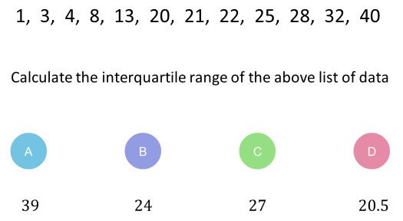 | Here are two sets of cards.  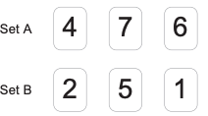  Are the two sets of cards mutually exclusive? Explain why.  Sets A and B are mutually exclusive because they do not coincide.  (2)  The universal set $Ω$ is all the positive numbers below 10. $A=\left\{1, 3, 5, 6, 7, 8, 9\right\}$ and $B=\left\{1,2,3\right\}$. Find the following:  - $A∩B$.  2/9  - $A∪B$.  8/9  - $A'∩B$.  1/9  (4)
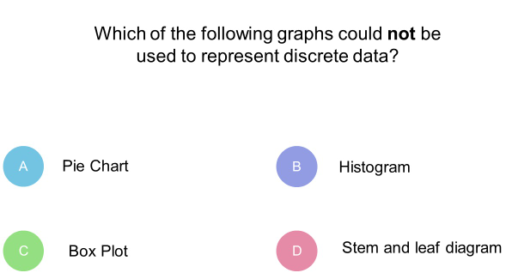
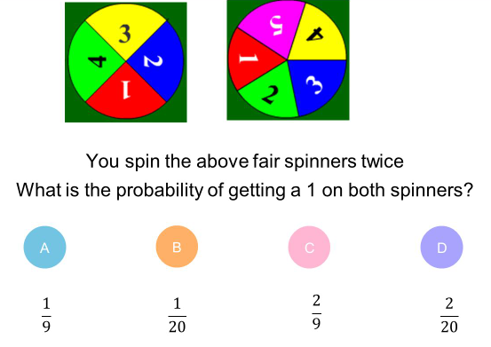
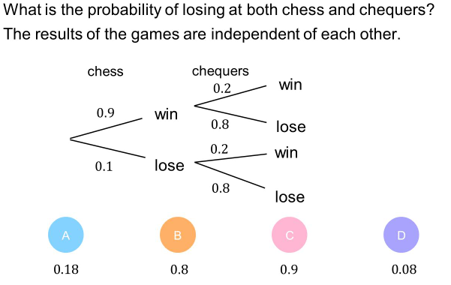
Quiz 3 for statistics and probability

